Nama : Tsaniya Faridah Maulida (211331031)
Partner : Erika Dwi Jayanti (211331006)
Kelas : 1A - TTE
Tanggal Praktikum : Jum’at, 11 Februari 2022

JURNAL PRAKTIKUM ELEKTRONIKA DIGITAL
GERBANG DASAR

  - Gambar Rangkaian

  - Hasil Percobaan
    - Gerbang NOT

A | F | Fv Simulator  (V) | Fv Real (V) | Gambar Praktikum  Simulator | Gambar Praktikum  Real
0 | 1 | 4,64 | 3,42 | 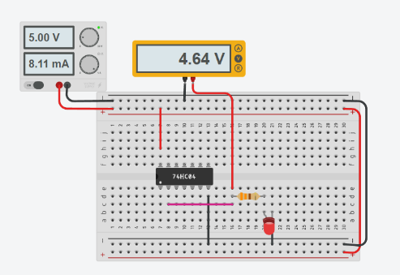 | 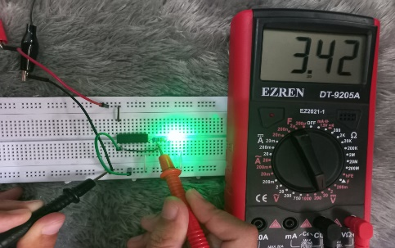
1 | 0 | 0 | 0,15 | 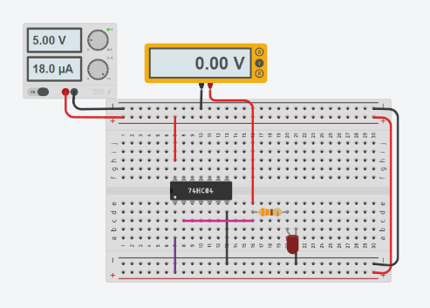 | 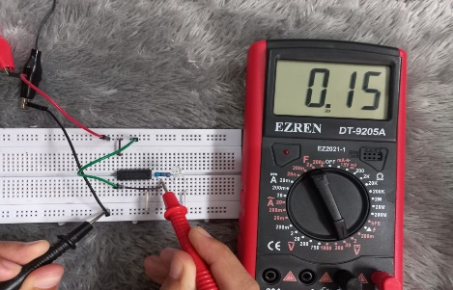

    - Gerbang AND

A | B | F | Fv Simulator (V) | Fv Real (V) | Gambar Praktikum  Simulator | Gambar Praktikum  Real
0 | 0 | 0 | 0 | 0,09 | 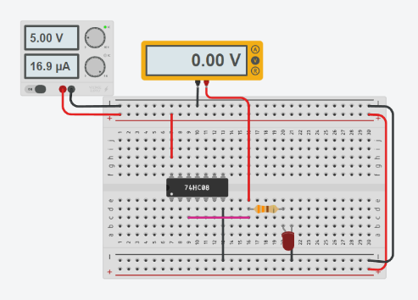 | 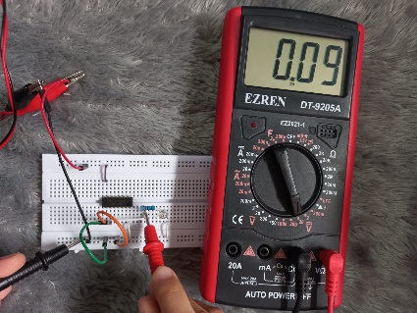
0 | 1 | 0 | 0 | 0,1 | 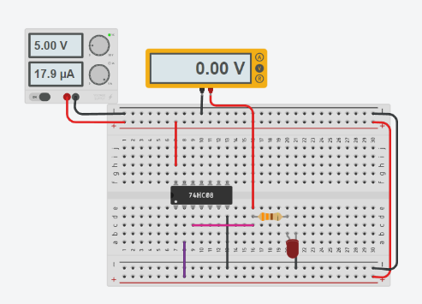 | 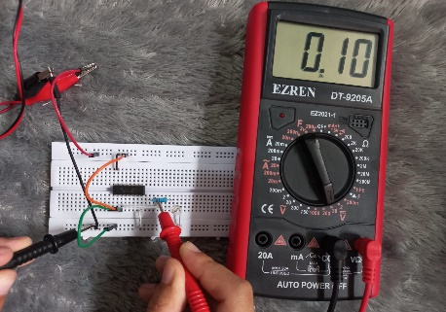
1 | 0 | 0 | 0 | 0,09 | 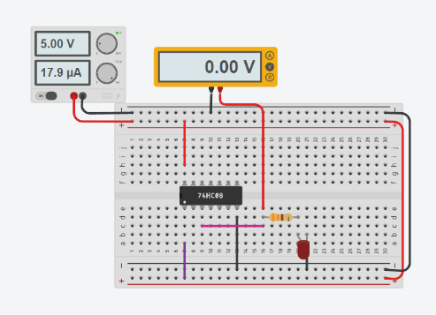 | 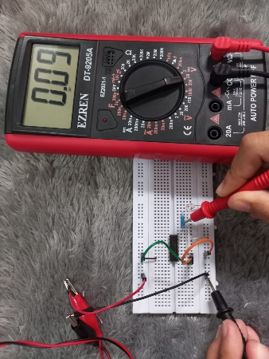
1 | 1 | 1 | 4,64 | 3,56 | 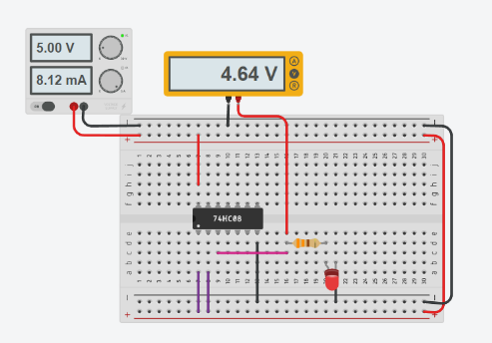 | 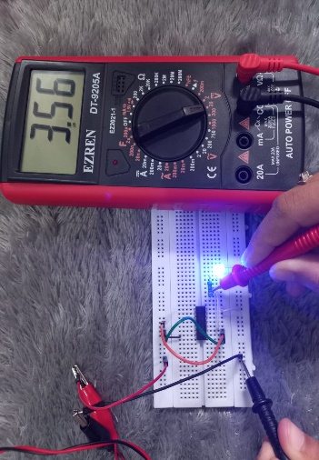

    - Gerbang OR

A | B | F | Fv Simulator (V) | Fv Real (V) | Gambar Praktikum  Simulator | Gambar Praktikum  Real
0 | 0 | 0 | 0 | 0,01 | 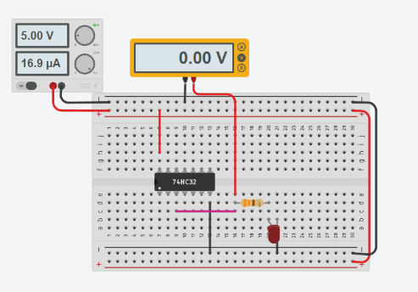 | 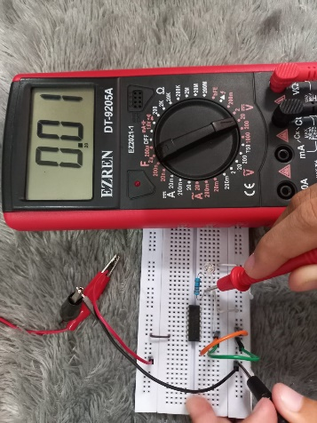
0 | 1 | 1 | 4,64 | 4,99 | 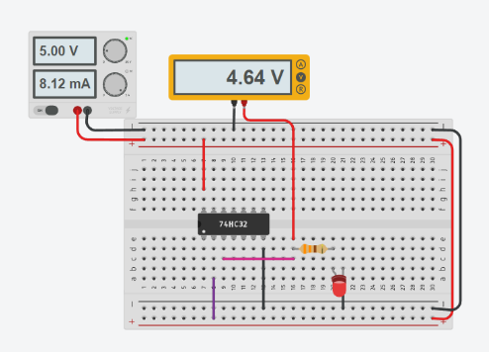 | 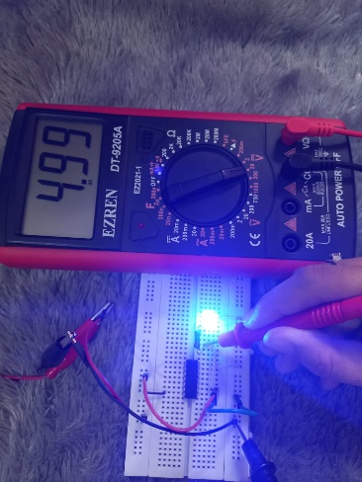
1 | 0 | 1 | 4,64 | 4,99 | 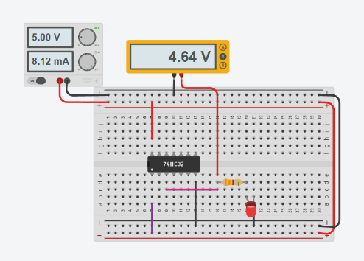 | 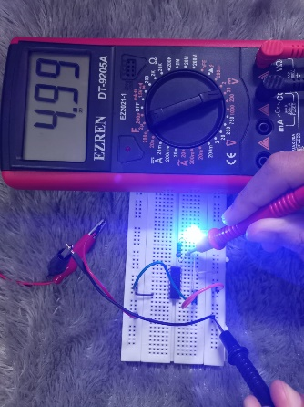
1 | 1 | 1 | 4,64 | 4,99 | 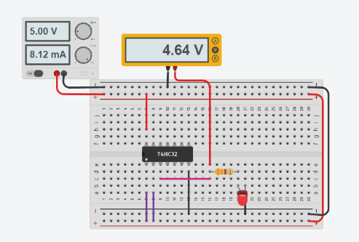 | 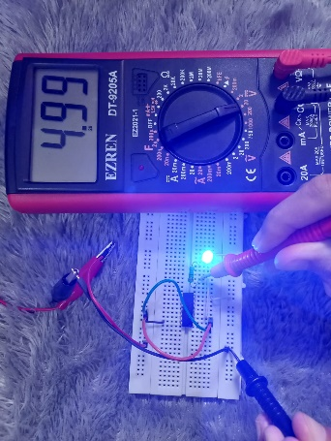

    - Gerbang NAND

A | B | F | Fv Simulator (V) | Fv Real (V) | Gambar Praktikum  Simulator | Gambar Praktikum Real
0 | 0 | 1 | 4,64 | 3,57 | 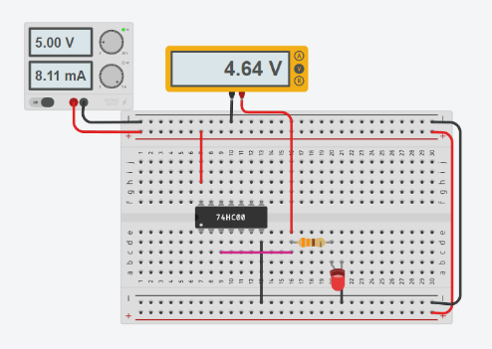 | 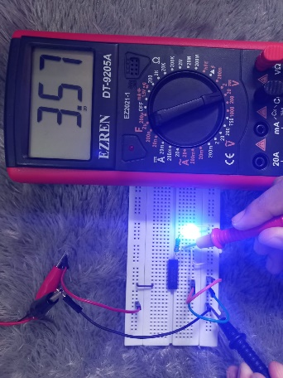
0 | 1 | 1 | 4,64 | 3,57 | 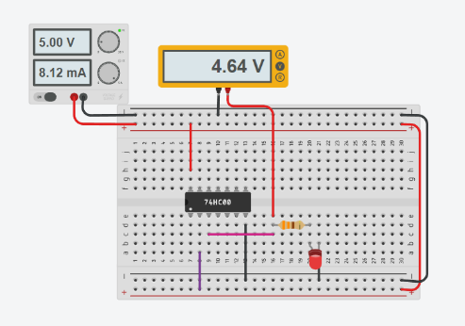 | 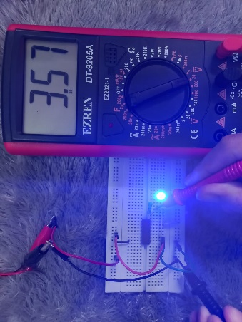
1 | 0 | 1 | 4,64 | 3,57 | 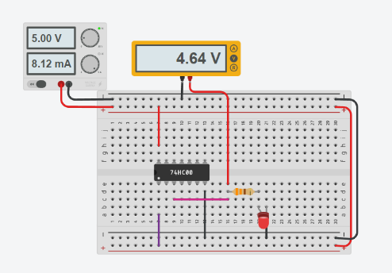 | 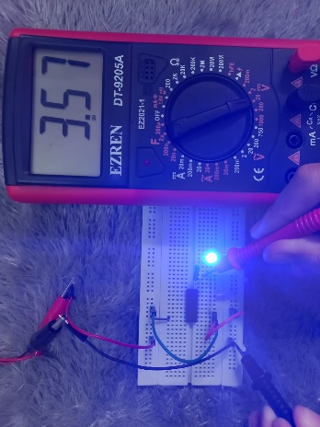
1 | 1 | 0 | 0 | 0,11 | 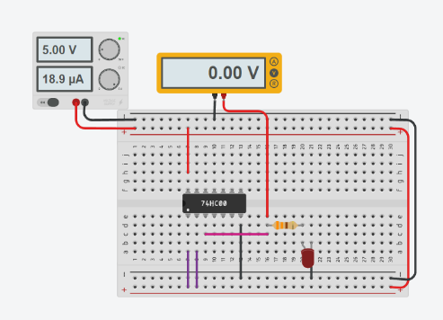 | 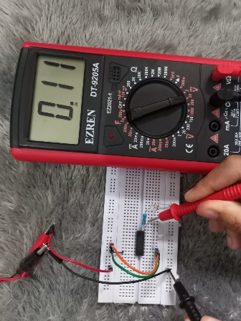

    - Gerbang NOR

A | B | F | Fv Simulator (V) | Fv Real (V) | Gambar Praktikum  Simulator | Gambar Praktikum  Real
0 | 0 | 1 | 4,64 | 3,38 | 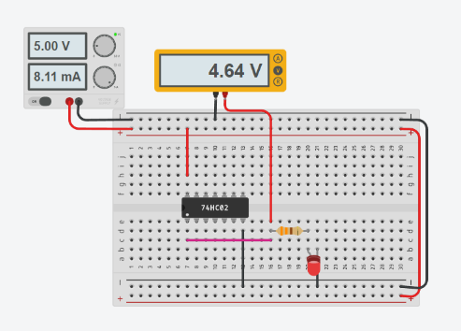 | 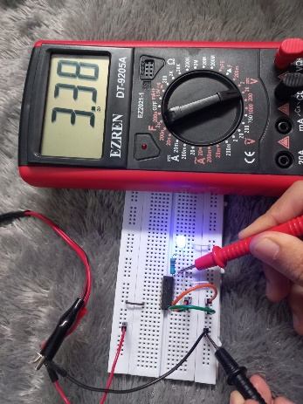
0 | 1 | 0 | 0 | 0,14 | 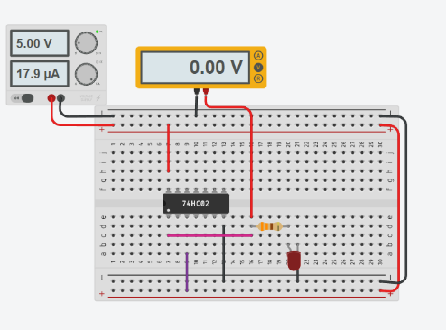 | 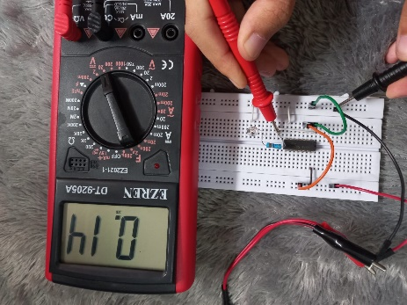
1 | 0 | 0 | 0 | 0,14 | 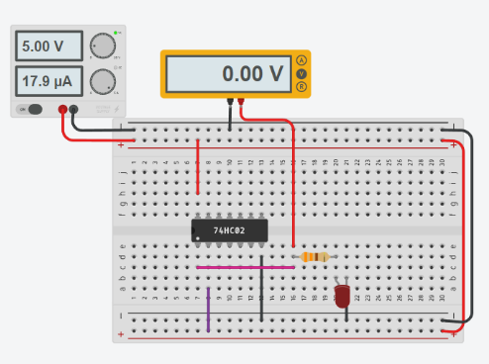 | 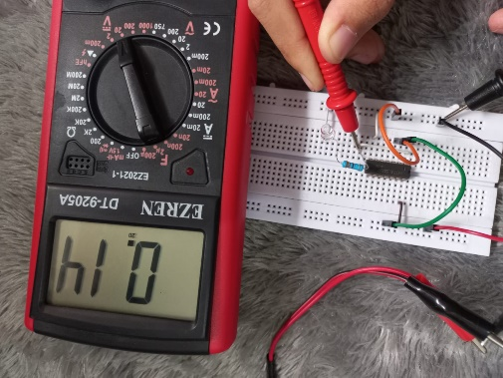
1 | 1 | 0 | 0 | 0,12 | 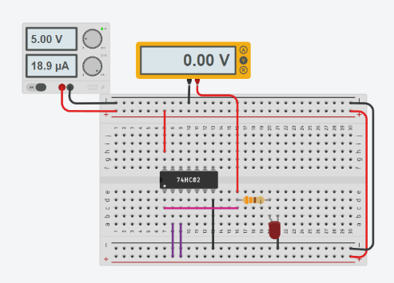 | 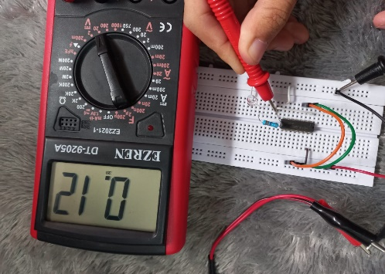

    - Gerbang EX-NOR

A | B | F | Fy Simulator  (V) | Fv  (V) | Gambar Praktikum Simulator | Gambar Praktikum Real
0 | 0 | 1 | 4,64 | 3,39 | 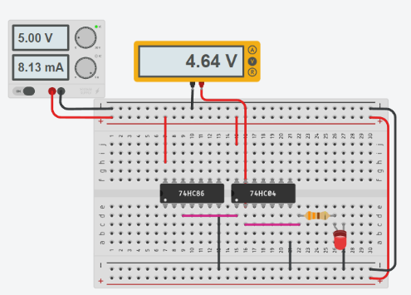 | 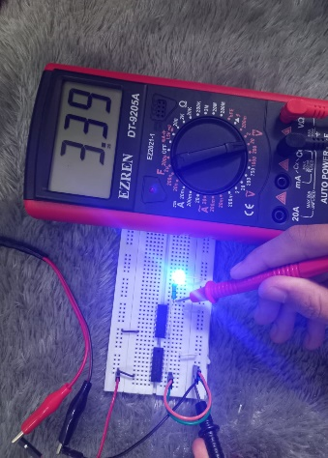
0 | 1 | 0 | 0 | 0,18 | 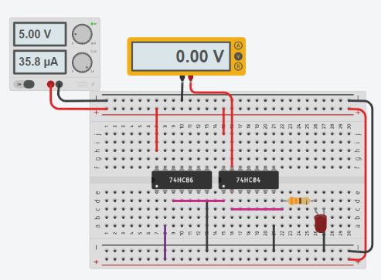 | 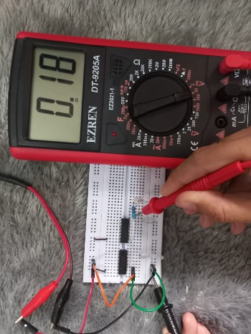
1 | 0 | 0 | 0 | 0,29 | 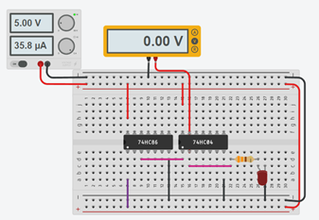 | 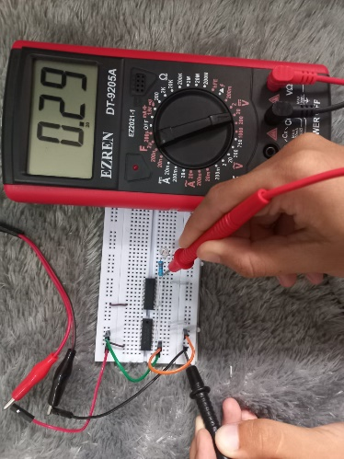
1 | 1 | 1 | 4,64 | 2,64 | 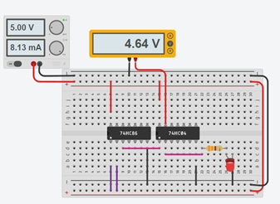 | 